**Summary of Excel Dashboard**

**Cozy cup Caffe Sales Dashboard**

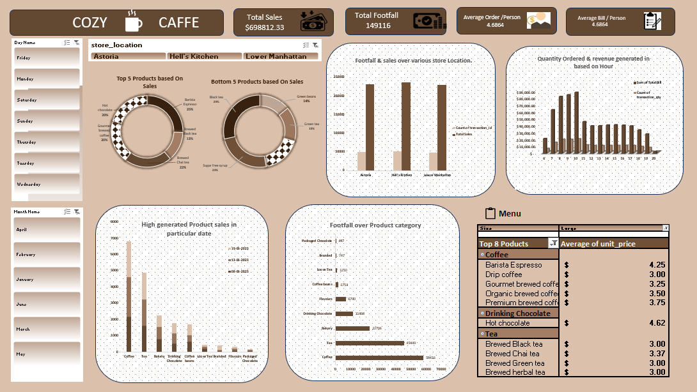

This **Cozy Caffe Sales Dashboard** provides an analytical overview of sales, footfall, product performance, and revenue trends. Below are the key insights:

**1. Overview Metrics**

* **Total Sales:** $698,812.33
* **Total Footfall:** 149,116 customers
* **Average Order per Person:** $4.6864
* **Average Bill per Person:** $4.6864

**2. Sales Performance Analysis**

* **Top 5 Selling Products:**
  + Hot Chocolate
  + Barista Espresso
  + Latte
  + Drip Coffee
  + Mocha
* **Bottom 5 Selling Products:**
  + Green Beans
  + Super Herbal Tea
  + Black Tea
  + Herbal Tea
  + Another Tea Variant (unclear)

**3. Store Location Analysis**

* Sales and footfall performance across three locations:
  + Astoria
  + Hell’s Kitchen
  + Lower Manhattan
* All three locations show high sales, but **Astoria and Lower Manhattan** seem to be performing better.

**4. Revenue Trends by Hour**

* Sales peak between **9 AM to 12 PM**, showing the most revenue generation.
* The decline starts after **4 PM** and continues towards the night.

**5. Product Category Insights**

* **Highest Selling Category:** Coffee (drives the most revenue).
* **Other Key Categories:** Tea, Drinking Chocolate, and Bakery items.

**6. Footfall & Sales Correlation**

* The footfall and sales are highest on specific days (likely weekdays).
* Detailed insights per product category show how customers interact with different items.

**7. Menu & Pricing Analysis**

* **Most Expensive Item:** Hot Chocolate ($4.62).
* **Popular Coffee Prices:**
  + Barista Espresso: $4.25
  + Drip Coffee: $3.00
  + Gourmet Brewed Coffee: $3.00
* **Tea Prices:**
  + Brewed Black Tea: $3.00
  + Brewed Chai Tea: $3.00
  + Brewed Green Tea: $3.00

**Conclusion & Recommendations**

1. **Focus on Morning Peak Hours:** Marketing campaigns, discounts, and promotions should be aligned with peak traffic times (9 AM - 12 PM).
2. **Store Performance Optimization:** Evaluate the **Lower Manhattan** store for potential improvements if its performance is lower.
3. **Boost Low-Performing Items:** Consider discounts or bundling offers on products like Green Beans and Herbal Teas.
4. **Menu Adjustments:** Hot Chocolate has a high price; promoting it during off-peak hours might help drive additional sales.
5. **Increase Footfall in Evenings:** Introduce happy hours or evening deals to counter the decline in sales after 4 PM.